NON-SASH WINDOW MEASUREMENTS

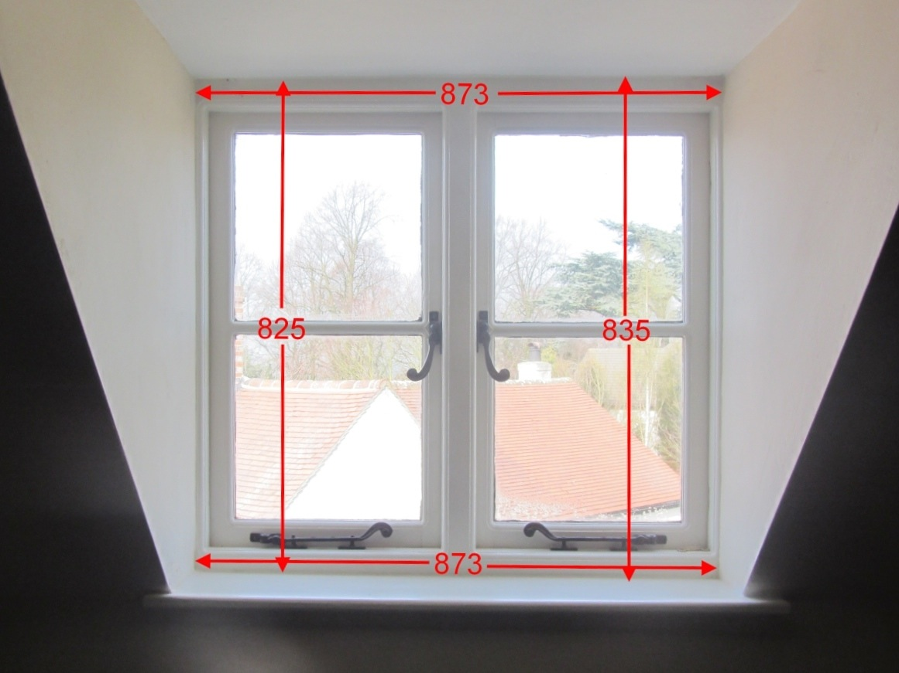
Please fill in measurements in mm in table below. Check both sides & top & bottom measurements
A

B

REF. | MEASUREMENT  in mm | ITEM | NOTES
window |  |  | number or name
A* |  | window width (int.) | measure reveal width
B* |  | window height (int.) | measure from underside of soffit to sill
E |  | floor to sill height | for child safety catch check if reqd.
K | 44mm | bracket (supplied) | fixed with 2 screws (supplied)
notes | please add any comments

NB. We will visually check dimensions against your photos

BW | BLIND WIDTH = | A - 10mm
BH | BLIND HEIGHT = | B

FABRIC COLOUR | standard or Agua pattern ref.
CHAIN TYPE | plastic, chrome, nickel, brass
CHAIN SIDE | left / right

